Function part 2

Main object:

1. Pass parameters by values
2. Pass parameters by reference
3. Default values for parameters.

Great sentences:

1. The only way for a function to see a variable from another function is for that variables to be passed as a parameter.
2. Check that input are one of the expected type and range. Once the input data is checked and known to be sound, another function / set of functions can process the data.
3. Pass all parameters by value: (for variable, I think…)

The formal parameters of a function only receive the values of the actual (calling) parameters. The function does not have access to the calling variable.

Parameters are always passed by value. However, if the value of the variable is a mutable object (like a list or other objects), then change to the internal state of the object will be visible to the calling function.

For instance, a list called A points / refers to a place, then the parameters B in the function also refers to this place, namely A and B points / refers to the same object / address.

Two identifiers for the same object, just the contents have been changed.

1. Pass parameters by reference: (for list or something else)

Allow variable themselves to be sent as parameters to a function.

Point to the same memory location,

Variables point to different memory location

The value of the variable is copied by the rate

Getting the updated list

List points to the memory location, where we get memory address, and that memory address is point to the list where we get all the elelments of the results

**Address is copied to the balance**

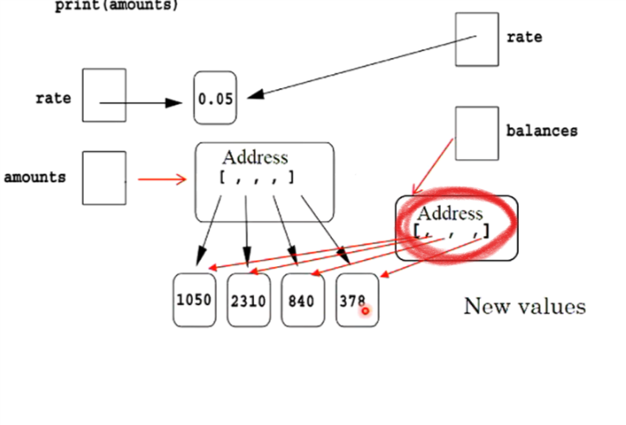

Default value of the parameters

1. the parameters with default values have to come after the positional parameters
2. only the important parameters (which come first) need by specified